Creating a Virtual machine using VMware

**Content**

Content 2

What is a virtual machine? 3

Virtualization 4

Hypervisors 5

Creating a virtual machine step by step 5

Step 1. 6

Step 2. 6

Step 3. 7

Step 4. 8

Step 5. 9

# What is a virtual machine?

A virtual machine is a virtual representation, or emulation, of a physical computer. They are often referred to as a guest while the physical machine they run on is referred to as the host.

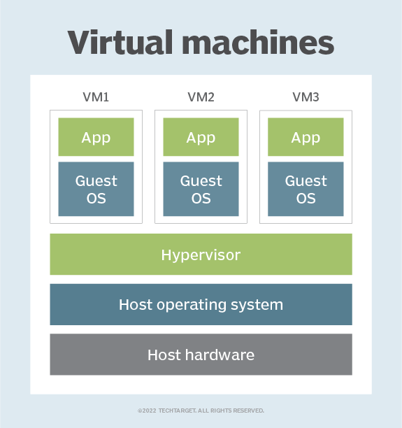 (Sheldon, 2023)

Virtualization makes it possible to create multiple virtual machines, each with their own operating system (OS) and applications, on a single physical machine. A VM cannot interact directly with a physical computer. Instead, it needs a lightweight software layer called a hypervisor to coordinate between it and the underlying physical hardware. The hypervisor allocates physical computing resources—such as processors, memory, and storage—to each VM. It keeps each VM separate from others so they don’t interfere with each other.

While this technology can go by many names, including virtual server, virtual server instance (VSI) and virtual private server (VPS), this article will simply refer to them as virtual machines. (IBM, 2023)

# Virtualization

Virtualization is a process that allows for more efficient utilization of physical computer hardware and is the foundation of cloud computing.

Virtualization uses software to create an abstraction layer over computer hardware that allows the hardware elements of a single computer—processors, memory, storage and more—to be divided into multiple virtual computers, commonly called virtual machines (VMs). Each VM runs its own operating system (OS) and behaves like an independent computer, even though it is running on just a portion of the actual underlying computer hardware.

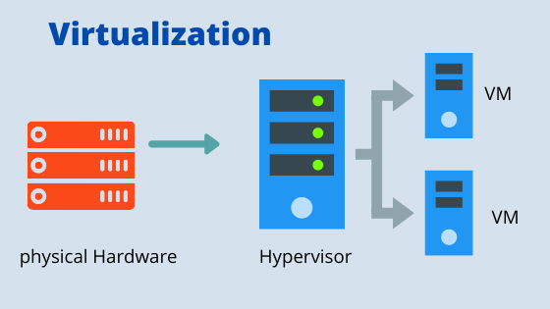 (Multifunction, 2023)

It follows that virtualization enables more efficient utilization of physical computer hardware and allows a greater return on an organization’s hardware investment.

Today, virtualization is a standard practice in enterprise IT architecture. It is also the technology that drives cloud computing economics. Virtualization enables cloud providers to serve users with their existing physical computer hardware; it enables cloud users to purchase only the computing resources they need when they need it, and to scale those resources cost-effectively as their workloads grow. (IBM, 2023)

## Hypervisors

A hypervisor is software that creates and runs virtual machines (VMs). A hypervisor, sometimes called a virtual machine monitor (VMM), isolates the hypervisor operating system and resources from the virtual machines and enables the creation and management of those VMs.

The physical hardware, when used as a hypervisor, is called the host, while the many VMs that use its resources are guests.

The hypervisor treats resources—like CPU, memory, and storage—as a pool that can be easily reallocated between existing guests or to new virtual machines.

All hypervisors need some operating system-level components—such as a memory manager, process scheduler, input/output (I/O) stack, device drivers, security manager, a network stack, and more—to run VMs.

The hypervisor gives each virtual machine the resources that have been allocated and manages the scheduling of VM resources against the physical resources. The physical hardware still does the execution, so the CPU is still executing CPU instructions as requested by the VMs, for example, while the hypervisor manages the schedule.

Multiple different operating systems can run alongside each other and share the same virtualized hardware resources with a hypervisor. This is a key benefit of virtualization. Without virtualization, you can only run 1 operating system on the hardware.

There are many choices for hypervisors from traditional vendors and open source. VMware is a popular choice for virtualization, and offers the ESXi hypervisor and vSphere virtualization platform.

Kernel-based Virtual Machine (KVM) is an open source option and is built into the Linux® kernel. Additional options include Xen, which is open source, and Microsoft Hyper-V. (Red Hat, 2023)

# Creating a virtual machine step by step

We will be using Oracle VirtualBox as our virtualization software for this guide.

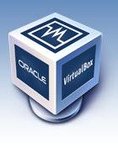

Before we begin, we must make our way to the website <https://www.virtualbox.org/> and find the option to download VirtualBox.

## Step 1.

Start VirtualBox and press ‘New’ in the menu

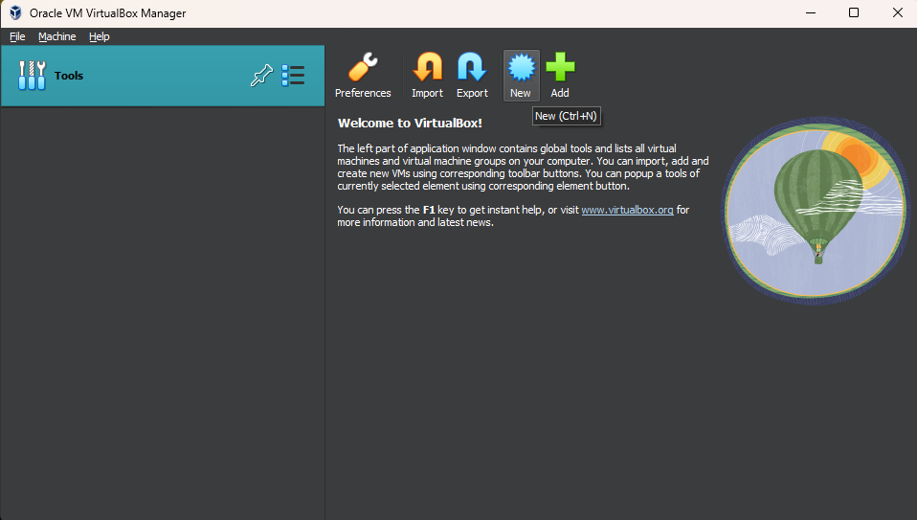

## Step 2.

Enter the name of the machine. Select OS and version.

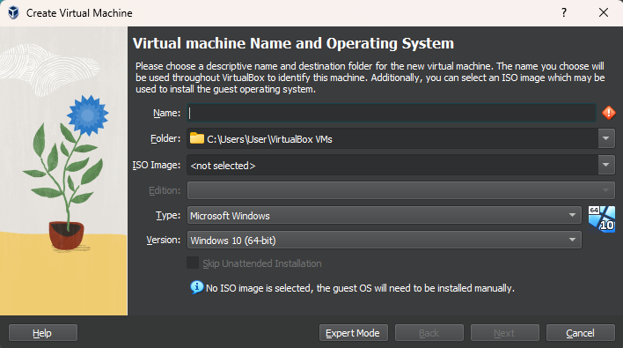

## Step 3.

Allocate virtual RAM and virtual CPU count. Make sure that this setting is set to the appropriate amount that is needed for your purposes.

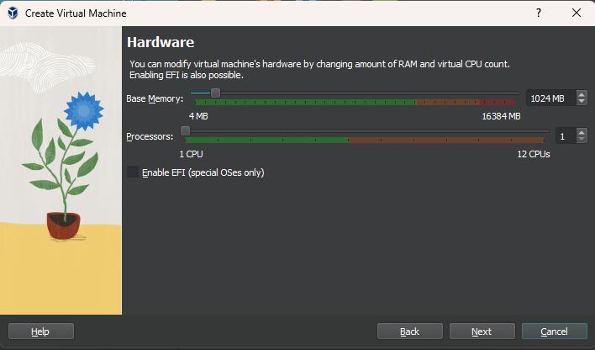

## Step 4.

Allocate virtual disk space or alternatively you can use an already existing virtual hard disk or choose not to use a virtual hard disk altogether.

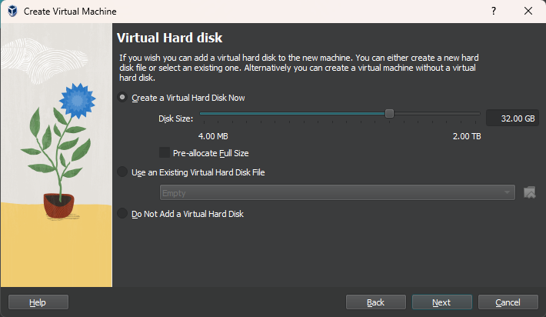

## Step 5.

Pressing ‘Start’ will launch the VM.

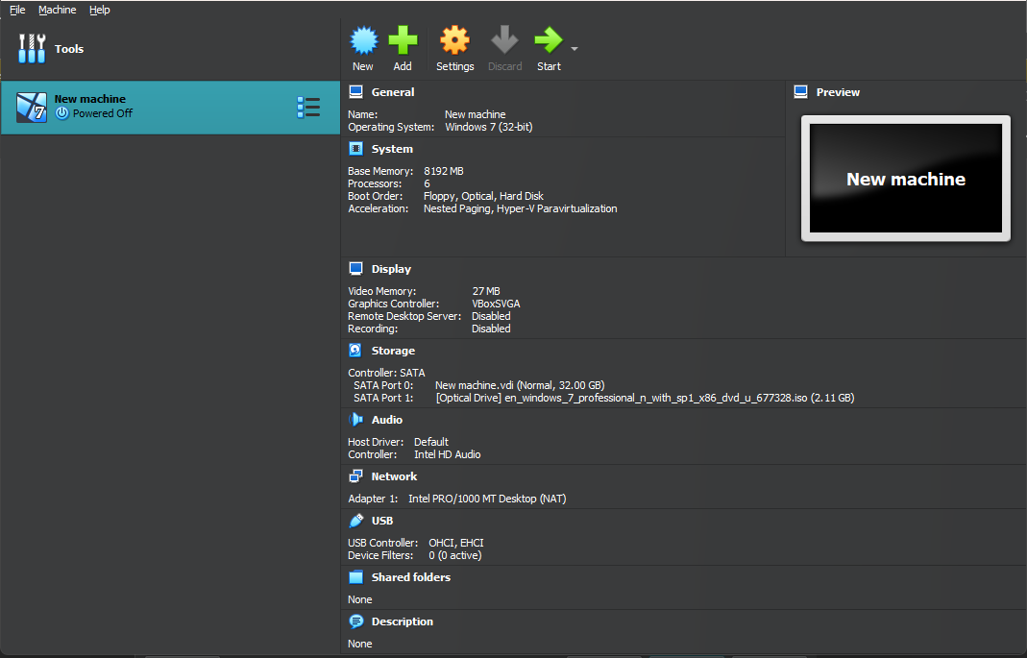

Once all these steps are completed you should be able to finish installing the OS inside the virtual machine and can install software as needed.

**References**

IBM. (2023). *What is Virtualization?* IBM. Retrieved November 30, 2023, from https://www.ibm.com/topics/virtualization

Red Hat. (2023, January 3). *What is a hypervisor?* Red Hat. Retrieved November 30, 2023, from https://www.redhat.com/en/topics/virtualization/what-is-a-hypervisor